Team Bravo:

Campbell

Hinkle

Luna

Orozco

Upadhyaya

Case Study: Bacchus Winery

**BUSINESS RULES:**

* MATERIAL ORDERS have one SUPPLIER
* SUPPLIER can have many MATERIAL ORDERS
* SUPPLY ORDERS have many MATERIAL
* DISTRIBUTORS have many DISTRIBUTOR ORDERS
* DISTRIBUTOR ORDERS can have many PRODUCTS

Initial ORD for Distributor Orders:

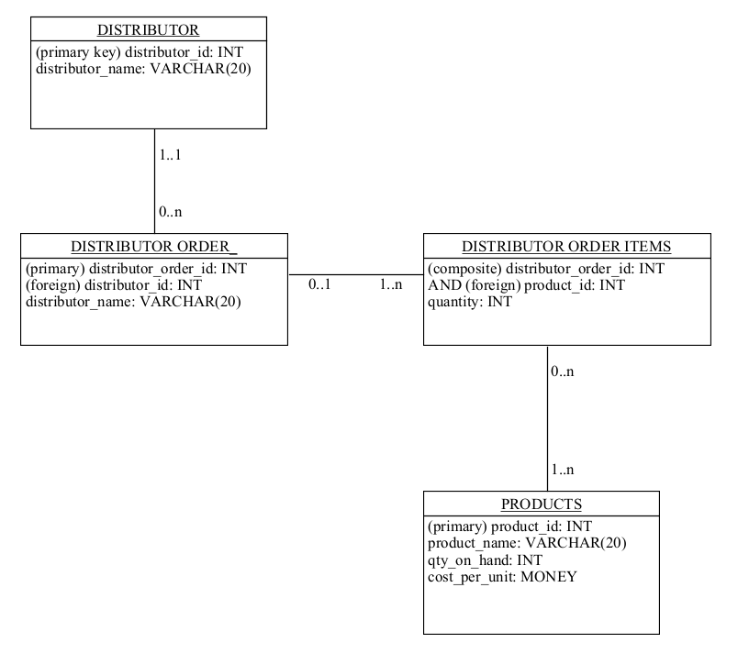

Initial ORD for Supplier Orders:

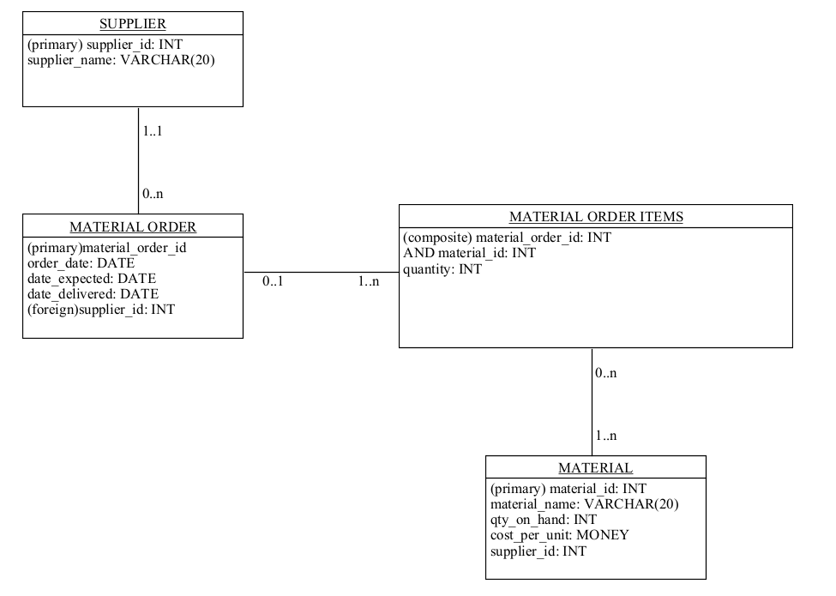

Initial ORD for Employee Payroll:

